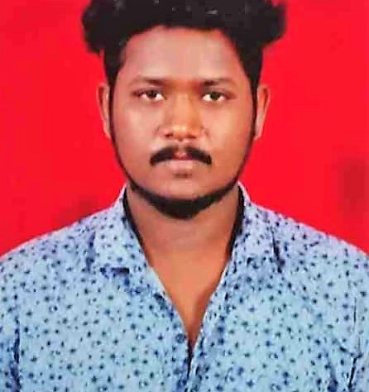 |  | KARNEKANTI NAVEEN  k.naveen1695@gmail.com
Profile  CAREER OBJECTIVES  An organized and motivated employee capable of time management and working under pressure in all environments  Seeking a position in a company where I can launch my career and build a valuable skill set  Contact  PHONE:  7731880253  ADDRESS:  Meerpet (500097), Hyderabad ,Telangana  EMAIL:  k.naveen1695@gmail.com  LINKEDIN PROFILE:  https://www.linkedin.com/in/karnekanti-naveen-66a71225b  Hobbies  Listening music  Travelling  Reading Books |  | EDUCATION HISTORY  [Bachelors of Engineering]  TKR COLLEGE OF ENGINEERING AND TECHNOLOGY  B-tech = Electrical And Electronics Engineering [EEE]  Year of passing = [2019 - 2023]  Aggregate = 6.6 CGPA  University = Jawaharlal Nehru Technology University (HYDERABAD)  [Class – XII ]  SRI CHANDRA JUNIOUR COLLEGE  Intermediate = Mathematics Physics Chemistry (MPC)  Year of passing = [2017 - 2019]  Aggregate = 60%  [Class – X ]  CHAITHANYA VIDYALAYAM SCHOOL  SSC = Secondary Education  Year of passing = [2016 - 2017]  Aggregate = 82%  TECHNICAL SKILLS  - dbms  - MS EXCEL  - MY SQL  - PYTHON – PROGRAMMING  - etl- power center

DECLARATION
I hereby declare that all the information furnished above is correct to the best of my
Belief . I am responsible for the authenticity of all the information

(NAVEEN)

